**CSE523: Machine Learning**

**Project Progress Report**

**Breast Cancer Detection**

**Group:  The Curators**

|  |  |
| --- | --- |
| **Name** | **Roll number** |
| **Harsh Patel** | **AU1940114** |
| **Kavan Desai** | **AU1940126** |
| **Sarthak Bharad** | **AU1940176** |

**Work done this week:**

* We have compared features of cells according to their definition and mathematical equation.

**Outcomes of the work done:**

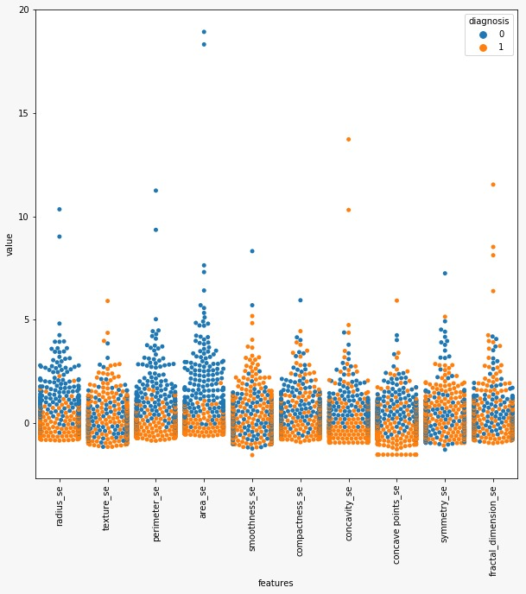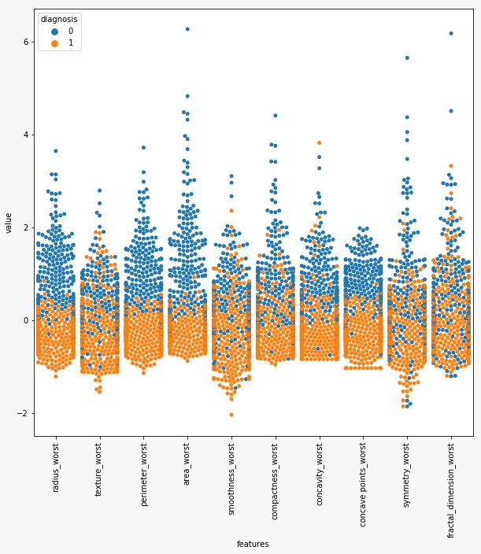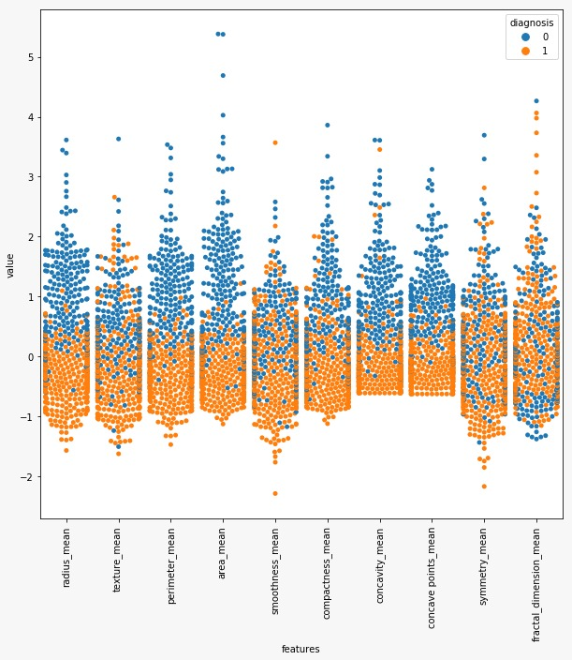

**LINK:-**[**Google collab**](https://colab.research.google.com/drive/12XEtj5SYwWTyFbtKGeiI4bBoaPnCyNAe#scrollTo=W9LZV_u7_lYq)

**Future work:**

* We will try to eliminate features based on the EDA that we have performed.
* We will be working on applying a different matrix for KNN.